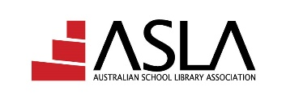

Australian School Library Association Inc

ABN 13 949 313 604

Access: National journal

2021 order form – Overseas subscribers only

An online journal published by the
Australian School Library Association Inc
Quarterly publication

Access is a professional online journal, which provides an open forum for all educators and researchers who are concerned with issues arising from digital literacy and school librarianship. Major foci include collaborative curriculum development, inquiry-based learning, information technology and its integration into learning/teaching programs, and information management.

Subscriptions – $AUD 110.00 (no GST for overseas subscribers)

SUBSCRIPTION ORDER FORM – Access

Send order to: PO Box 9106, Deakin ACT 2601, Australia

Phone: 0439 358 607 email: asla@asla.org.au

Contact person ___________________________________________________
School/Library ____________________________________________________
Address _________________________________________________________
________________________________________________________________
Phone ______________________ * Email __________________________
Order number ________________

Payment details:

Cheque enclosed for $AUD 110.00

(Please make cheques payable to Australian School Library Association Inc)

Please invoice

Credit Card payment: Mastercard Visa

Card number ___ ___ ___ ___ ___ ___ ___ ___ ___ ___ ___ ___ ___ ___ ___ ___
Name on Card ________________________________________________
Expiry date ___________
Signature _______________________________
CVV (3 digit code on back of card) ___ ___ ___
Total amount in Australian dollars $ _______________

