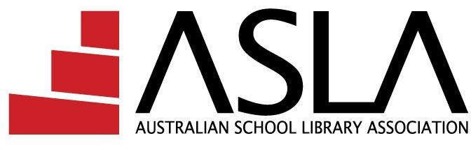

A SLA Nomination Form – 2021

Name of nominee:
Please print name
Nominee’s address:
Phone Number:
Email:

Position for which being nominated for 2021 (please check one)
Office Bearers
President
Vice President
Director

Please note: The Nominee, Nominator and Seconder must be current members of ASLA.

Nominated by:
Please print name
Nominator’s address:
Nominator’s email:
Signature:
Date:
Seconded by: Please print name
Seconder’s address:
Seconder’s email:
Signature:
Date:

I hereby accept nomination for the above position on the ASLA Board.

Nominee’s qualifications:
Nominee’s current work position:
Nominee’s previous work-based positions:

Nominee’s previous organisational positions and dates held:
Professional activities: (limit:70 words)
Statement of professional commitment to ASLA: (limit: 120 words)
Note: The information above may be used in the election materials distributed to all ASLA members.

Nominee's Endorsement:
I am a financial member of the Australian School Library Association and resident in Australia.
I have read and understood the role and responsibilities of the office for which I am nominated. https://asla.org.au/role-statements

I am not aware of any conflicts of interest, that is any interest or activity that is contrary to or competing with the interests of the Association that could impact on the acceptance of my application.

I acknowledge that all Board deliberations, including conversations during Board meetings, emails and other Board communications are confidential and are not to be passed to third parties unless approved by all Board members.

I understand Directors are volunteers and shall not receive payment for work undertaken except compensation for services rendered or expenses incurred on behalf of the Association. I have provided information which may be used in the publicity for this election process.
I accept the nomination for this position.
Signature of candidate: Date:

Nominations should be sent to:

ASLA Secretary: secretary@asla.org.au

Nominations must be submitted to the Secretary in writing by: 5pm on 11 February 2021

The next Annual General Meeting of the Australian School Library Association will be held online at the ASLA/SLASA Conference on Tuesday 13 April 2021.

